**Editor and IDE - eclipse**

**Downloading and Installing eclipse:**

Eclipse can be downloaded from : <http://www.eclipse.org/downloads/>

Here is a screenshot of the above link

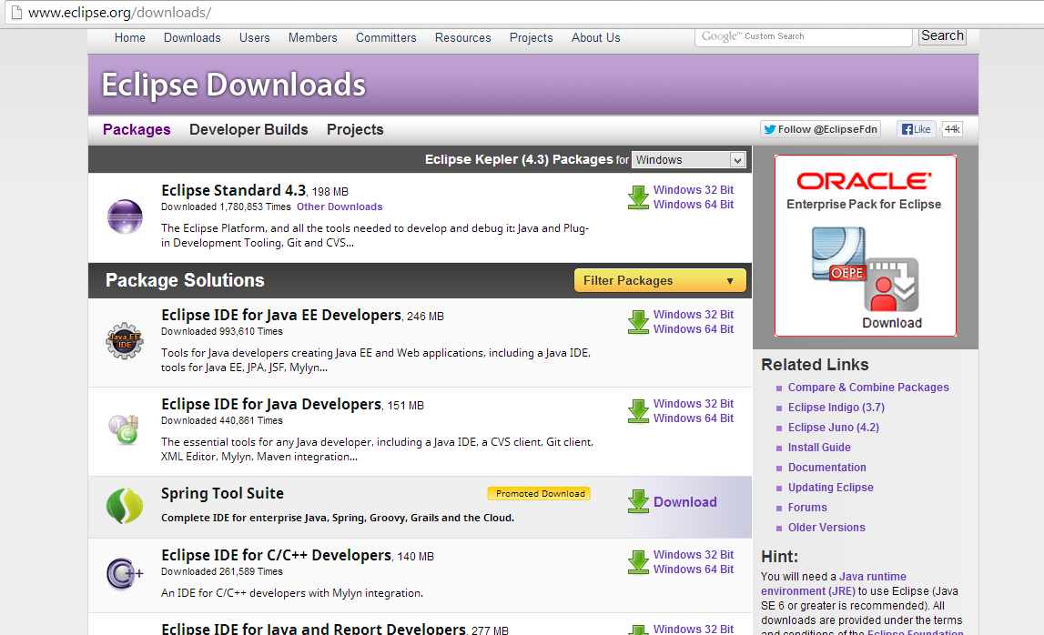

Select Eclipse IDE for java EE developers and press download. After the download has been completed, extract it, this would give an eclipse folder , under this and double click on eclipse.exe , this would start eclipse. Select a workspace i.e. ) a folder where all the programs will be stored.

Here is a screenshot on how it would look.

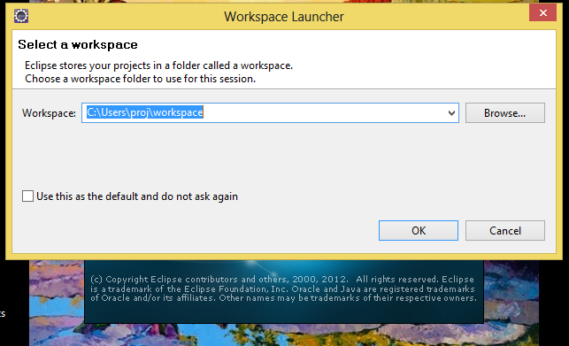

Eclipse has now been installed!

**Creating a new project:**

To create a new java project ,Select File - New -Other..., this would lead to the screen as shown below 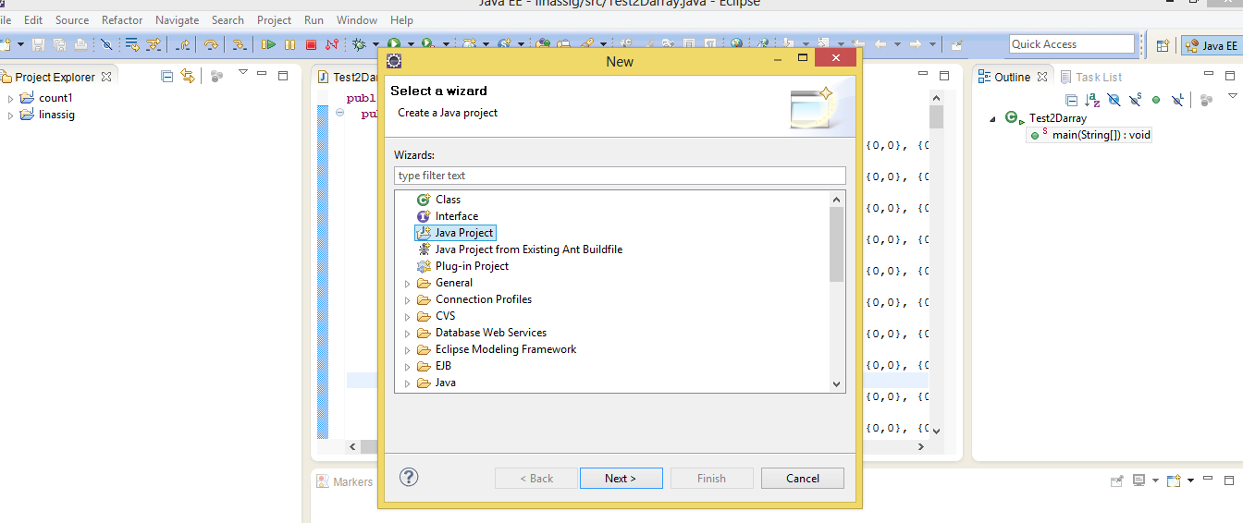Select Java Project this would give the below screen. Enter a name under Project name and click Finish.

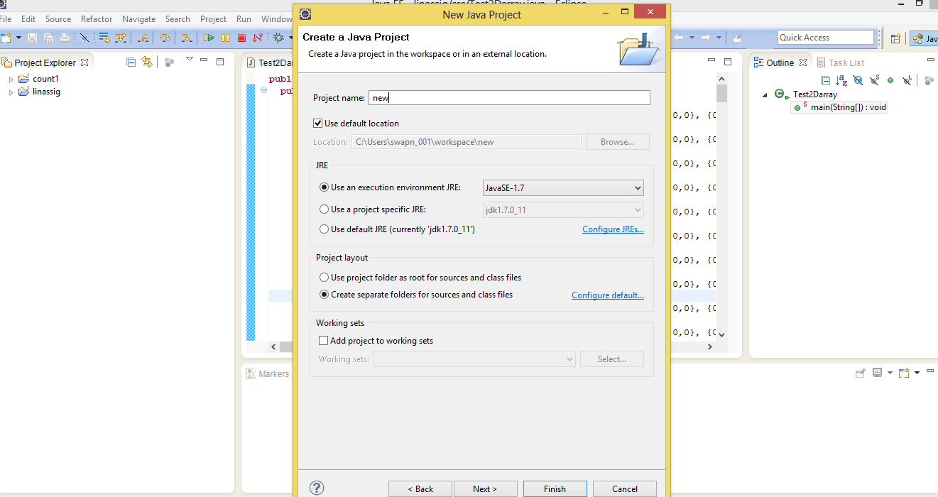

**How to Run a java program** :

After the programming is complete , select the Run option to run the program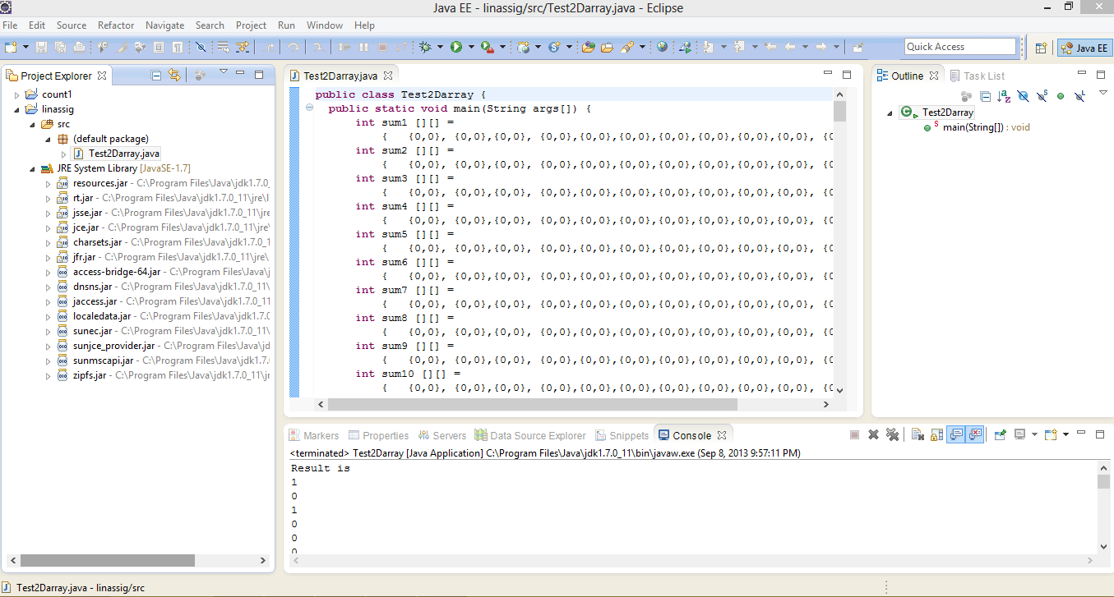

**Error Logs:**

If there are errors in the program the error log can be seen in the console

